Grade 7 Accelerated · Unit 6 · Lesson 3  Pythagorean Theorem  Independent Set 6.03 | Name______________________  Date______________________  Period____________________

Six questions, on your own, in silence. Show the step that does the work.
1. A right triangle has legs of 12 m and 5 m. How long is the hypotenuse?

2. A right triangle has legs of 3 ft and 8 ft. How long is the hypotenuse, exactly and to the nearest tenth?

3. A right triangle has a hypotenuse of 39 cm and one leg of 36 cm. How long is the other leg?

4. A right triangle has a hypotenuse of 11 in and one leg of 4 in. How long is the other leg, exactly and to the nearest tenth?

5. A right triangle is drawn turned on its side. Its legs are 6 m and 11 m. How long is its hypotenuse, to the nearest tenth?
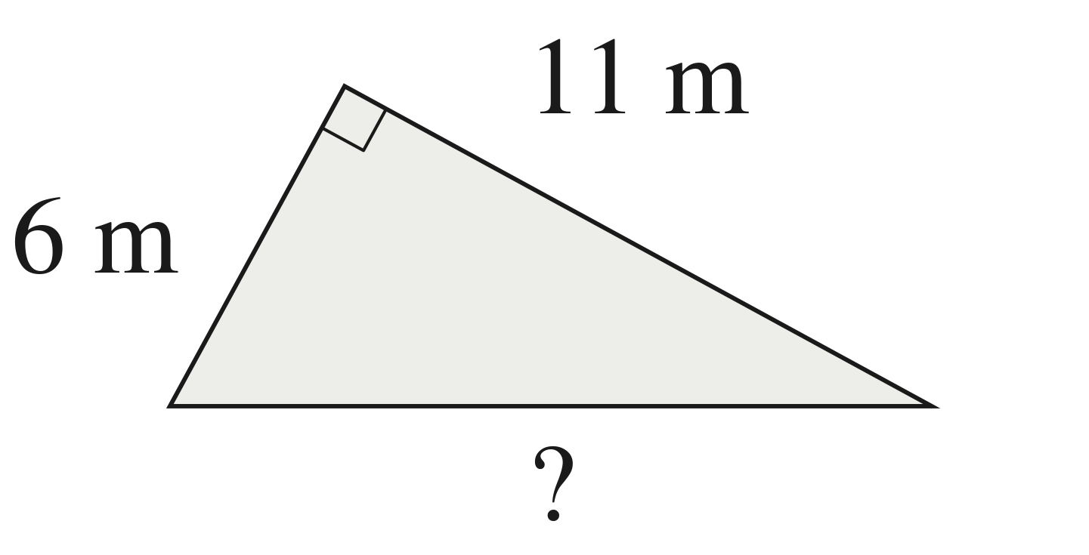

6. A right triangle has a hypotenuse of 25 yd and one leg of 24 yd. The other leg is x. Write the equation that finds x, then find x.

